Lab Exercise 11 - Build Custom Rules with Starlark

Objective
- Understand Starlark language
- Create custom Bazel build rules
- Use MODULE.bazel (Bzlmod)
- Integrate custom rules with C++
- Execute and validate build outputs correctly

Prerequisites
- Bazel 7+ installed
- C++ compiler (MSVC / GCC / Clang)
- Basic knowledge of BUILD files
Part 1: Project Setup
Directory Structure
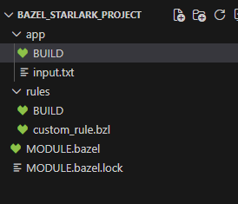

Part 2: MODULE.bazel (Bzlmod Setup)
Create MODULE.bazel:
module(
name = "bazel_starlark_project",
version = "1.0",
)
bazel_dep(name = "rules_cc", version = "0.2.17")

Part 3: Create Required BUILD Package
Important Note
Bazel requires every .bzl file to belong to a package.
Create:
rules/BUILD
Content:
# Empty BUILD file (required)

Part 4: Input File
Create app/input.txt:
hello bazel starlark cpp lab

Part 5: Custom Starlark Rule
Create
rules/custom_rule.bzl
def _uppercase_impl(ctx):
input_file = ctx.file.src
output_file = ctx.actions.declare_file(ctx.label.name + ".txt")

ctx.actions.run_shell(
inputs = [input_file],
outputs = [output_file],
command = "cat {} | tr 'a-z' 'A-Z' > {}".format(
input_file.path,
output_file.path,
),
)

return DefaultInfo(files = depset([output_file]))

uppercase_rule = rule(
implementation = _uppercase_impl,
attrs = {
"src": attr.label(allow_single_file = True),
},
)

Part 6: BUILD File (Final Correct Version)
app/BUILD
load("@rules_cc//cc:defs.bzl", "cc_binary")

load("//rules:custom_rule.bzl", "uppercase_rule")

uppercase_rule(
name = "convert_text",
src = "input.txt",
)

Part 8: Build and Execution
Step 1: Clean Build
bazel clean

Step 2: Build Custom Rule
bazel build //app:convert_text

Step 5: View Output
bazel-bin/app/convert_text.txt

